Practical - 7

Practical Title: PHP Form Processing with Server-Side Validation and CSV/JSON File Storage

Problem Definition: Process submitted registration/contact form data using PHP. Validate and
sanitize inputs on the server side and store records in CSV or JSON file
format. Display success/error messages.

Theory:
1. Is the form submitted using POST?
Yes, the form is submitted using the POST method. It sends the user's registration or contact details to the PHP server without displaying the form data in the URL.
2. Are inputs validated and sanitized server side?
Yes, the inputs are validated and sanitized on the server using PHP. Validation checks whether the required fields are filled correctly, while sanitization removes or handles unwanted characters to ensure safer data processing.
3. Is file writing handled safely?
Yes, file writing is handled safely by checking the submitted data and using PHP file-handling functions. The records are stored in CSV or JSON format, and file locking can be used to prevent conflicts during simultaneous writes.
4. Are success and error responses displayed clearly?
Yes, clear success messages are displayed when the data is stored successfully. If any input is invalid or a file-writing error occurs, an appropriate error message is shown to the user.

- Implementation/ Output/Result
https://github.com/margiruparel2907-collab/webdev/tree/master/Prac_7

- Evidence of Work (Screenshots)
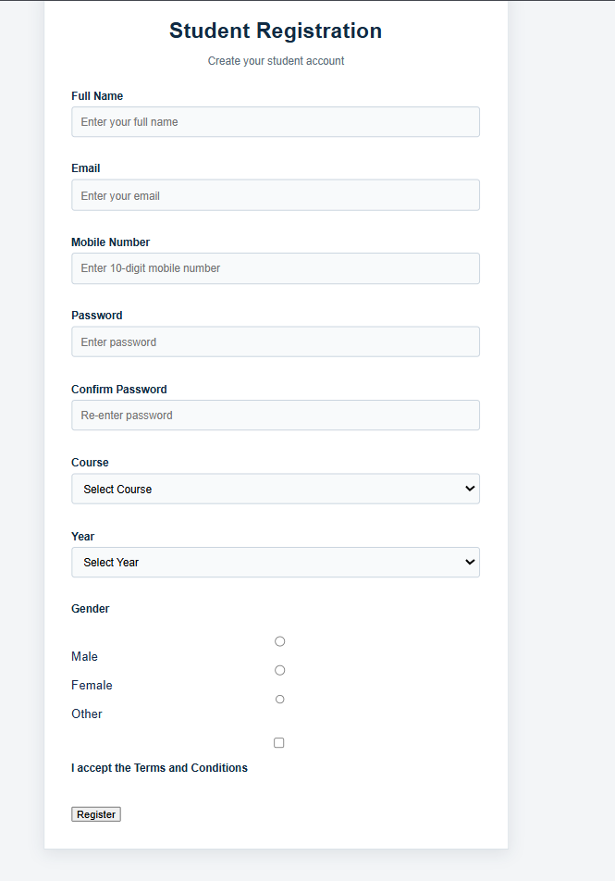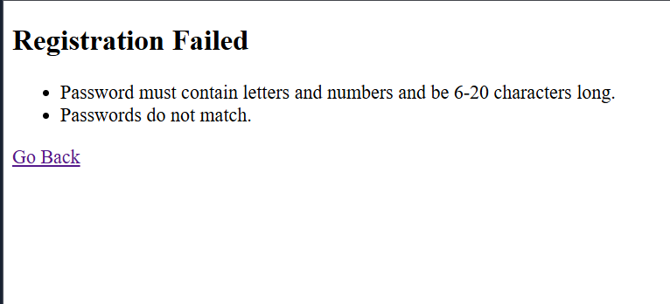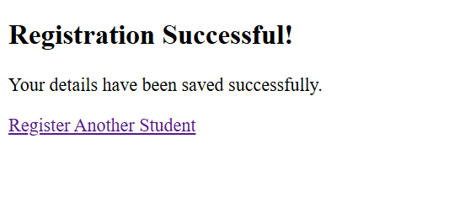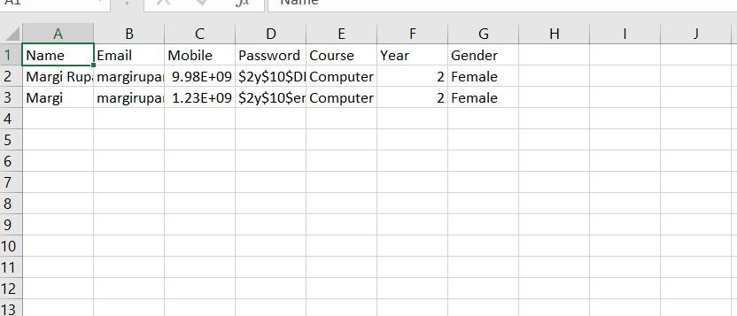
- GitHub Repository Link:
https://github.com/margiruparel2907-collab/webdev

- Challenges Faced:
During this practical, I faced challenges in handling form data using the POST method, validating and sanitizing user inputs, and storing the submitted information in CSV or JSON files. I also learned to handle file-writing errors and display appropriate success and error messages.
- Learning Outcomes:
Through this practical, I learned how to process HTML forms using PHP, validate and sanitize user inputs on the server side, and store records safely in CSV or JSON files. I also understood how to handle errors and display clear feedback to users after form submission.

Faculty Remarks: (Keep this blank for faculty)

